Great — here is the best explanation of Angular Components by mapping them to Spring Boot, so you can understand it immediately in your own backend language.
I will explain each Angular concept by comparing it with a Spring Boot analogy.

✅ Angular Component Mapped to Spring Boot (Backend → Frontend Mapping)
Think of an Angular Component as similar to a Spring Boot Controller + Service + HTML page combined into one unit.

🔥 1. Angular Component = Spring Boot Controller (logic) + HTML (view) + CSS (style)
Angular Component (Frontend)
- .ts → logic
- .html → UI / view
- .css → styling
- @Component → connects files
- Must be registered inside a Module
Spring Boot (Backend)
- Controller → handles logic
- Thymeleaf/JSP → frontend view (if using MVC)
- .css → styling
- @Controller → maps URL and view
- Must be declared inside the project / spring context
So, an Angular Component is like:
👉 One Controller + One HTML File + One CSS File
bundled together to form a UI unit.

✅ 2. Angular .ts file = Spring Boot Controller + Service Logic
Angular:
export class HomeComponent {
title = "Welcome";
getData() { ... }
}
Spring Boot Equivalent:
@RestController
public class HomeController {
@GetMapping("/data")
public String getData() { ... }
}
Mapping:
- Angular .ts handles functions, events → like controller logic
- It also calls APIs → same as service layer in Spring

✅ 3. Angular HTML Template = Spring Boot View (Thymeleaf/JSP)
Angular:
<h1>{{title}}</h1>
Spring Boot:
<h1 th:text="${title}"></h1>
Both display dynamic data.

✅ 4. Angular CSS File = Styling for That Component
Same as writing a .css file for your Spring MVC template.
Angular component CSS applies only to that component → like scoped CSS.

✅ 5. Angular @Component = Spring Boot @Controller Annotation
Angular:
@Component({
selector: 'app-home',
templateUrl: './home.component.html'
})
Spring Boot:
@Controller
@RequestMapping("/home")
Both:
- link logic + view
- define where they are used
- part of the application context

✅ 6. Angular Module (NgModule) = Spring Boot Application Class
Angular:
All components must be registered inside:
@NgModule({
declarations: [HomeComponent]
})
export class AppModule {}
Spring Boot:
All controllers/services are automatically scanned under:
@SpringBootApplication
public class MyApp {}
Angular needs manual declaration;
Spring Boot uses component scan.

🧩 DIAGRAM (Mapped to Spring Boot)
Angular Component Spring Boot Equivalent
+---------------------------+ +--------------------------------+
| .ts (Logic) | ---> | Controller + Service |
+---------------------------+ +--------------------------------+
| .html (UI Template) | ---> | Thymeleaf/JSP HTML View |
+---------------------------+ +--------------------------------+
| .css (Styling) | ---> | Static CSS File |
+---------------------------+ +--------------------------------+
| @Component Decorator | ---> | @Controller Annotation |
+---------------------------+ +--------------------------------+
| NgModule (app.module) | ---> | @SpringBootApplication |
+---------------------------+ +--------------------------------+

⭐ Short Interview Answer (Mapped to Backend)
"Sir, the Angular Component is exactly like a combination of a Spring Boot Controller, HTML view, and CSS file.
The TypeScript file works like controller/service logic, the HTML file is the view layer, and the CSS file handles styling.
These three are connected using the @Component decorator, similar to how @Controller connects Java logic with a view in Spring MVC.
Every component must also be registered inside an Angular Module, similar to how Spring components are registered in the application context."

If you want, I can also map:
✔ Angular Services → Spring Services
✔ Angular Modules → Spring Boot Modules
✔ Angular Dependency Injection → Spring DI
✔ Angular Routing → Spring Boot REST Routing
Just tell me.
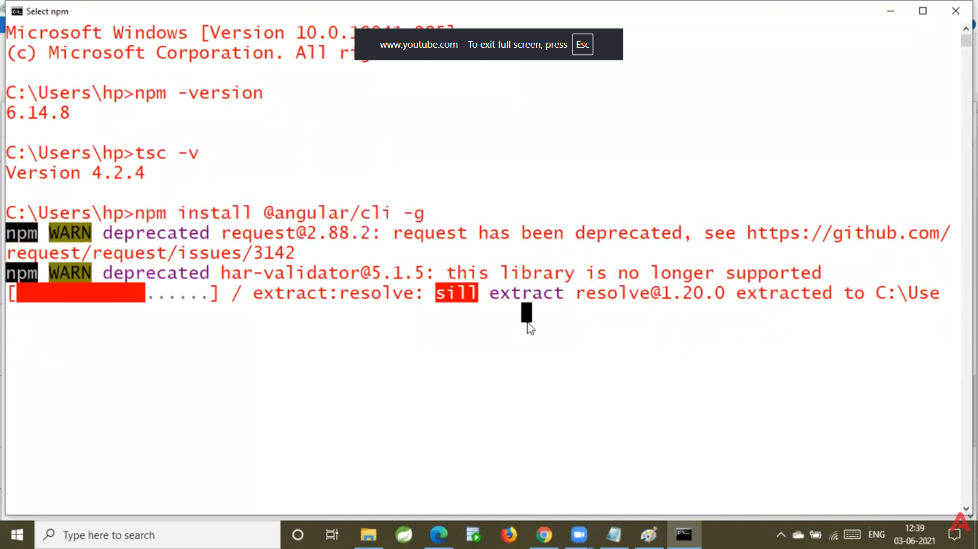
Below is the clearest, simplest mapping of Angular components to Spring Boot MVC, so you understand Angular easily using your Spring Boot knowledge.
This mapping will make everything crystal clear.

🎯 BIG PICTURE MAPPING
Angular | Spring Boot (MVC) | Meaning
Component | Controller + HTML | UI + logic for the screen
Template (HTML) | Thymeleaf JSP HTML | View to show data
Component TS File | Controller Service Logic | Handles UI logic
Service (Angular) | Service Layer | Business logic + API calls
Model (Interface/Class) | Entity / DTO | Data structure
Module (NgModule) | Spring Boot Configuration Class | Organizes pieces of app
Routing Module | URL mappings (@GetMapping, @PostMapping) | Controls navigation
Dependency Injection | @Autowired | DI system
HTTPClient | RestTemplate / WebClient | Makes API calls
Observable / RxJS | CompletableFuture / Async Calls | Handles async data
Angular App | Spring Boot Application | Main entry point

🎯 1. Angular Component = Spring Controller + UI Page
Angular
@Component({
selector: 'app-student',
templateUrl: './student.component.html'
})
export class StudentComponent {
title = "Student Page";
}
Spring Boot
@Controller
public class StudentController {

@GetMapping("/student")
public String studentPage(Model model) {
model.addAttribute("title", "Student Page");
return "student.html";
}
}
✔ Mapping
- Angular component has TS + HTML + CSS
- Spring Controller returns HTML view with data
So Component = Controller + View

🎯 2. Angular Service = Spring Boot Service Layer
Angular Service
@Injectable()
export class StudentService {
getStudents() {
return this.http.get('/api/students');
}
}
Spring Boot Service
@Service
public class StudentService {
public List<Student> getStudents() {
return repo.findAll();
}
}
✔ Both handle business logic
✔ Angular service also calls API using HttpClient

🎯 3. Angular Model = Spring Boot Entity / DTO
Angular
export interface Student {
id: number;
name: string;
}
Spring Boot (Entity)
public class Student {
private int id;
private String name;
}
✔ Structure of data is same
✔ Angular uses interface or class
✔ Spring uses class

🎯 4. Angular Module = Spring Configuration / Application Context
Angular Module
@NgModule({
declarations: [AppComponent],
imports: [BrowserModule, FormsModule],
})
export class AppModule {}
Spring Boot
@SpringBootApplication
public class MyApplication {}
✔ Organizes components, services, modules
✔ Similar to how Spring loads beans and configuration

🎯 5. Angular Routing = Spring MVC URL Routing
Angular
const routes = [
{ path: 'students', component: StudentComponent }
];
Spring Boot
@GetMapping("/students")
public String getStudents() {}
✔ One defines front-end route
✔ One defines back-end endpoint

🎯 6. Angular HttpClient = RestTemplate / WebClient
Angular (Frontend)
this.http.get('/api/students')
Spring Boot (Backend calling another API)
restTemplate.getForObject("/api/students", Student.class)
✔ Same purpose: calling APIs

🎯 7. Observable (Angular) = Async Processing (Spring)
Angular Observable:
this.studentService.getStudents().subscribe(data => {});
Spring Boot async:
CompletableFuture.supplyAsync(() -> service.getData());
✔ Handles asynchronous data
✔ Angular uses RxJS
✔ Spring uses CompletableFuture or WebFlux Mono/Flux

🎯 8. Angular Project = Spring Boot Project Structure
Angular Structure
app/
components/
services/
models/
modules/
Spring Boot Structure
com.app
controller/
service/
model/
config/
✔ Very similar folder mapping

⭐ FINAL SUPER SIMPLE MAPPING (NEVER FORGET)
Angular | Spring Boot
Component | Controller + HTML
Service | @Service
Model | Entity / DTO
Module | @Configuration / @SpringBootApplication
Routing | @GetMapping / @PostMapping
HttpClient | RestTemplate / WebClient
Observable | CompletableFuture / Reactor
AppComponent | Main controller/view
AppModule | SpringApplication

🎉 Do you want VISUAL DIAGRAM mapping Angular → Spring Boot?
I can draw a clear diagram that connects:
✔ Angular Component → Spring Controller
✔ Angular Service → Spring Service
✔ Angular Module → Spring Boot Config
✔ Angular Routing → Spring MVC Routing
Just say "give diagram"!

